1.F  1.G |   Harmonize 2  + workbook
2.F |   Harmonize 2  + workbook  Harmonize 3  + workbook
3.F  3.G | 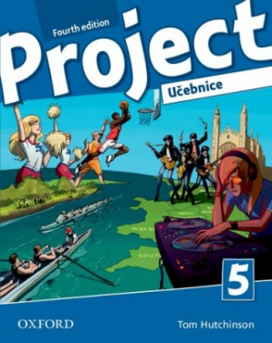  Project 5  + workbook
4.F  4.G | 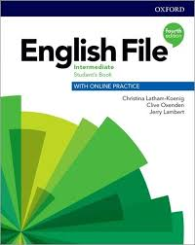  Project 5  + workbook  English File  Intermediate  4th ed.

